DATE: 30.11.2018
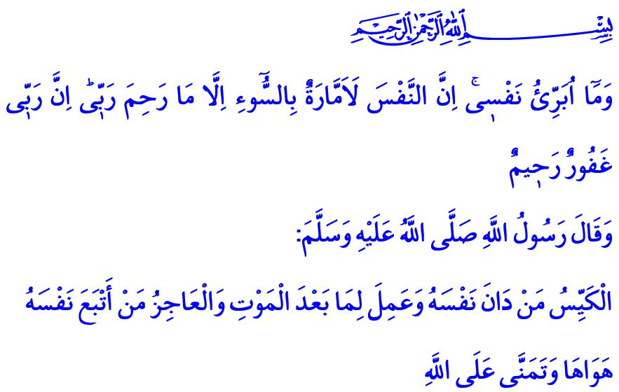NAFS: THE BATTLEGROUND BETWEEN GOOD AND EVIL
Honorable Muslims!
The most precious member of the universe of existence is the human being who is the addressee of revelation. Being the most honorable being of the earth brings along the trial as well as the blessing. Human beings are sometimes tested by fear, hunger, their life and children, and sometimes by possession, wealth, authority, and position. One of the greatest tests is the struggle of human beings with their nafs.
Nafs is the inner source of negative emotions, illegitimate wishes, bad habits and acts of the servants. This feature of the nafs is described in the Holy Qur’an by the words of the Prophet Yusuf (Joseph) as follows: “And I do not acquit myself. Indeed, the nafs is a persistent enjoiner of evil, except those upon which my Lord has mercy. Indeed, my Lord is Forgiving and Merciful.”
Valued Believers!
Allah the Almighty (swt) has created human beings in the most beautiful way, and has equipped them with a sound mind, a firm will and a profound heart. He has bestowed upon them the Qur’an and the exemplary of the prophets to distinguish right from wrong. He (swt) commanded them to use His blessings properly and fight against their boundless, self-defiant desires. Those who make right choices, control their own will, say “Stop!” to their nafs, purify themselves of their sins, and correct themselves can attain salvation. Those who succumb to the desires of their nafs, who are captived by their evil desires and cannot control them by using their mind are doomed to be disappointed. Our Sublime Lord (swt) reminds us of this issue in the Holy Qur’an as: “And [by] the nafs and He who proportioned it; and inspired it [with discernment of] its wickedness and its righteousness, He has succeeded who purifies it, and he has failed who instills it [with corruption].”

Esteemed Muslims!
Nafs is the battleground between the good and the evil. The history of humankind is full of examples of people and societies who have driven themselves to devastation by following their nafs. One of the sons of the Prophet Adam (as), Qabil killed his brother Habil, motivated by his ambition, malice, or following his nafs in other words. The sons of the Prophet Yaqub (as) (Jacob) threw their brother Yusuf into the well because of their jealousy and becoming captives of their nafs. Fir’awn, Namrud, Qarun, Abu Jahl, and similar people all followed their nafs, turned their back on the guidance of the revelation, and by feeling confident in their throne, power, wealth, and own self, they finally became destroyed in this world and doomed to the punishment in the Hereafter.
Honorable Muslims!
It is essential for believers not to curse their nafs, but to train it and equip it with good qualities; keep it under control for any desire against the boundaries drawn by Allah (swt), morality and conscience; and stand by what is good and by the good people while standing against what is evil and the evil people.
Esteemed Believers!
“The clever person is the one who subjugates his soul, and works for what is after death. And the incapable is the one who follows his desires and merely hopes in Allah.” said the Messenger of Allah (saw). So let us not pursue our nafs that fancies the deceptive colors of the temporary world. Let us always keep our mind, our will, and our patience alive. Let us always keep in mind that life is a test, and that death and the account of the Hereafter may come suddenly. Let us live with the awareness that our Sublime Lord (swt) sees each and every state of us whether it be secret or open. Thus, away from the darkness of the kufr or denial of the truth and free from the burden of the sins, let us become peaceful, perfect and absolute believers. I would like to conclude my khutbah with the following prayer of our Beloved Prophet (saw): “O Allah grant to my soul the sense of piety and purify it, for You are the Best Purifier thereof. You are the Protecting thereof, and Guardian thereof. O Allah, I seek refuge in You from the knowledge that does not benefit, from the heart that does not entertain the fear (of Allah), from the soul that does not feel contented, and from the supplication that is not responded.”

Yusuf, 12/53.
Shams, 91/ 7-10.
Tirmidhi, Sifat al-Qiyamah, 25; Ibn Majah, Zuhd, 31.
Muslim, Dhikr, 73. General Directorate of Religious Services

